

Mawlana Bhashani Science and Technology University

Lab-Report

Lab Report No: 01
Lab Report Name: How to install Linux Operating System
Course code: ICT-3110
Course title: Operating System Lab
Date of Performance:
Date of Submission:

Submitted by Submitted To
Name : Maskur Al Shal Sabil
ID: IT 18021
3rd year 1st semester
Session : 2017-2018
Dept of ICT
Nazrul Islam
Assistant Professor
Dept. of ICT,
MBSTU.

1 . Linux Operating System :

Linux is an open source operating system or a kernel first released on September 17, 1991, by Linus Torvalds . It is an operating system just like Windows, iOS, and Mac OS .An operating system is software that manages all of the hardware resources associated with desktop or laptop. Simply the operating system communicate with the software and hardware .

The Linux operating system comprises several different types of pieces :
1. Bootloader : Bootloader is a piece of code that runs before any operating system is running which manages the boot process of the computer. For most users, this will simply be a splash screen that pops up and eventually goes away to boot into the operating system.
2. Kernel : Kernel is the central module of Linux which manages the CPU, memory, and peripheral devices. It is the lowest level of Operating system.
3.Init system : Init (initialization) is the first process started during the during booting of the computer system. It is a daemon process that continues running until the system is shut down.

4. Daemon : Daemon is a computer program that runs as a background process provide services (printing, sound, scheduling, etc.) that either start up during boot or after user log into the computer.
5. Graphical server : It is the graphical user interface that displays the graphics in the monitor.
6. Desktop environment : Desktop environment is the distribution where the user actually interact . There are many desktop environments to choose from (GNOME, Cinnamon, Mate, Pantheon, Ubuntu,Kali, Redhat, Enlightenment, KDE, Xfce , etc.). Each desktop environment includes built-in applications (such as file managers, configuration tools, web browsers, and games).
7. Applications : Desktop environments do not offer all the application the user needed . Just like other Os it provides thousands of software that can be easily found and installed.

2. Linux distribution
Linux has a number of different distribution to suit any type of user . All versions are based on linux provides different flavor of Linux as the user need . Every distribution of Linux is free .
The popular Linux distribution are noted below :
- MANJARO
- LINUX MINT
- DEBIAN
- UBUNTU
- ANTERGOS
- SOLUS
- FEDORA
- ELEMENTARY OS
- OPENSUSE
- RED HAT
- KALI
Each distribution has a different take on the desktop .Some opt for very modern user interfaces (such as GNOME and Elementary OS’s Pantheon), whereas others stick with a more traditional desktop environment (openSUSE uses KDE).
3 . Installation process of Linux Operating system
We know that Linux is open source ,free to use kernel. It is used by programmers,students, organizations, profit and non-profit companies in around the world to create Operating systems to suit their own demand. For this reason it has many distribution. Here we discuss about the installation process of ubuntu distribution .
Installation can be done by the following ways :
1. In Virtual Box
2. Dual boot

So here we interpret the installation process in Virtual Box :
Download the Virtual box and ubuntu iso file
link : https://www.virtualbox.org/wiki/Downloads
link :https://www.ubuntu.com/download/desktop
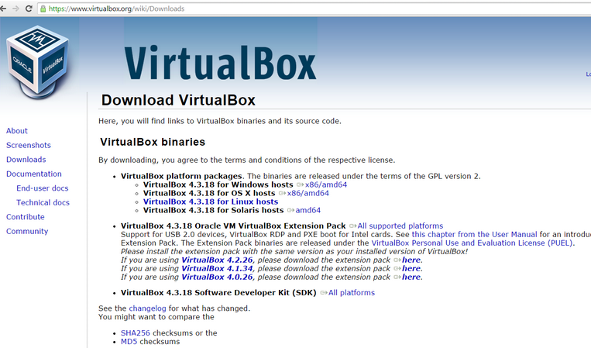
And then run the virtual box on your computer.

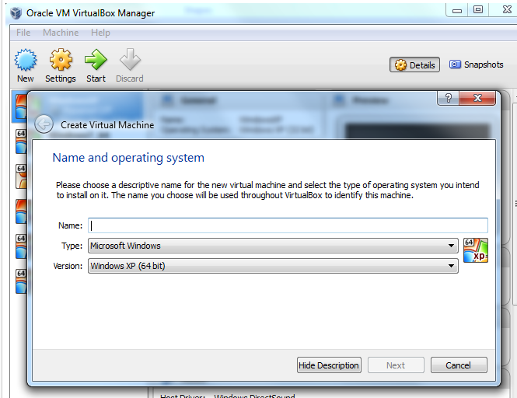
Run and create virtual machine

And then we named it as ubuntu since we install ubuntu and the versions 64 bti

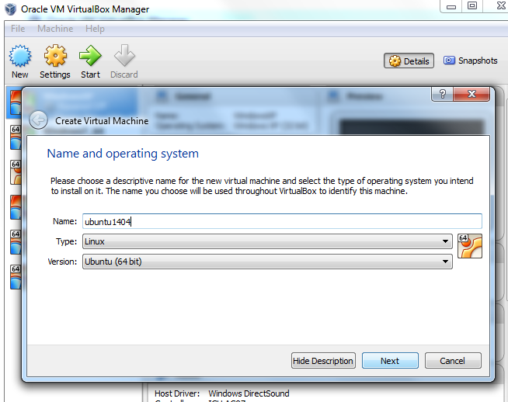

set the memory size depending upon your ram it should be varied. Set at least 4GB for better performance or 2GB
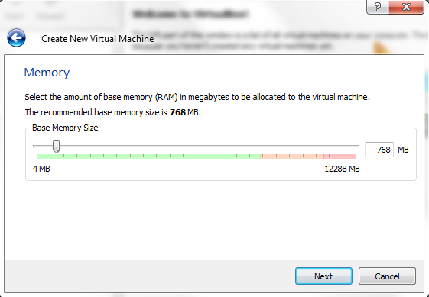

Accept the default create hard drive
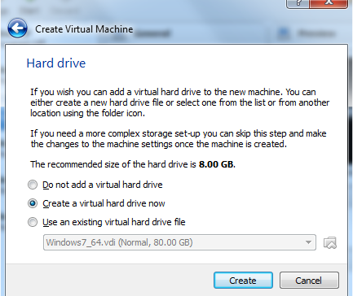

Continue to accept the default 'VDI' drive file type and click 'Next' button
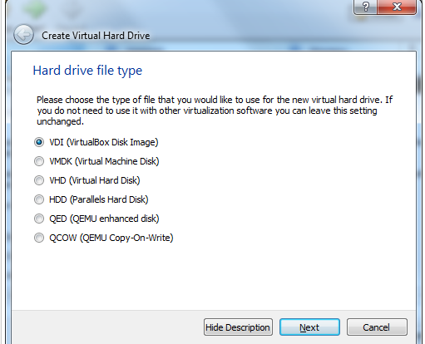

Select memory dynamically allocate
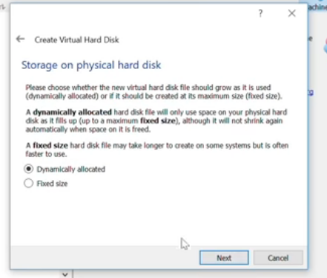

Select file location and memory
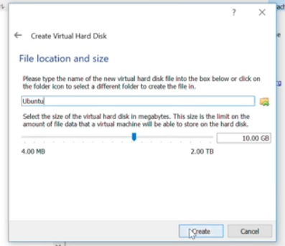

start ubuntu

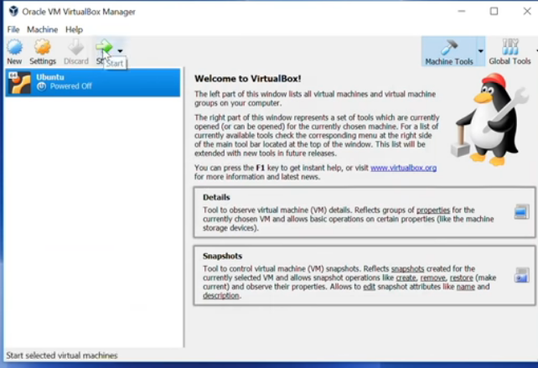

set the iso file of ubuntu

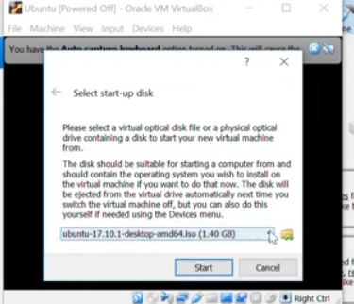

Wait and then you will get the window select install
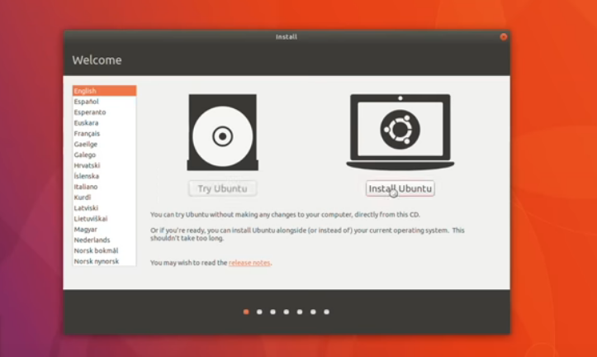

Dont worry just select erase disk and install ubuntu
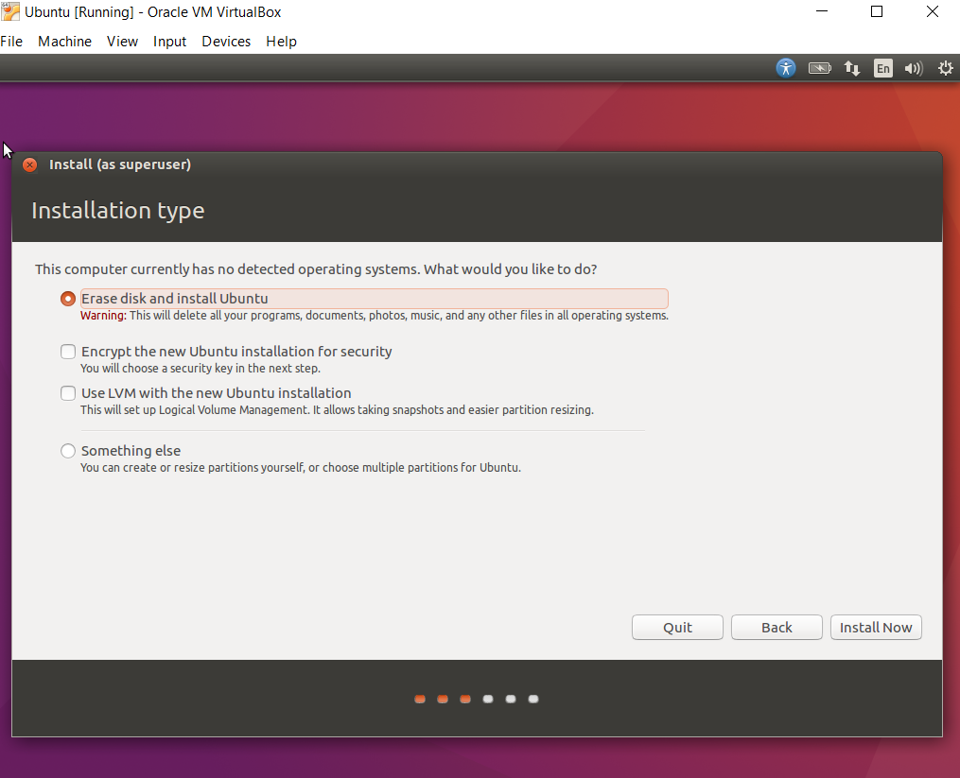
continue and select your location on the map
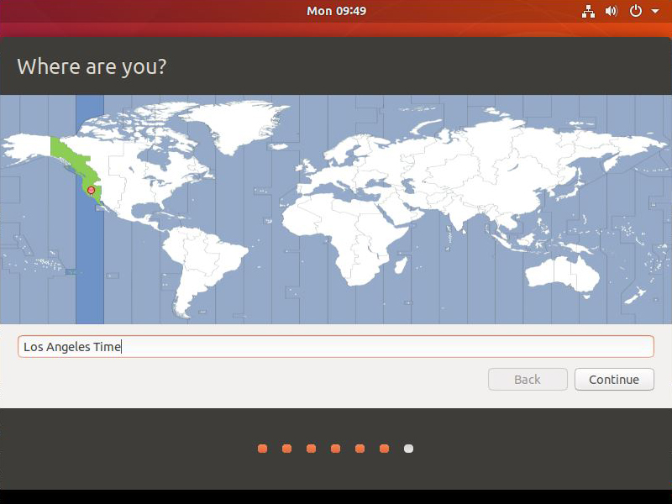

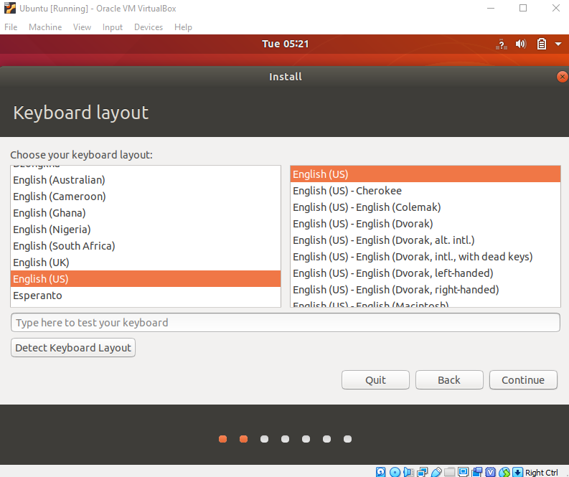
choose the key board lalyout
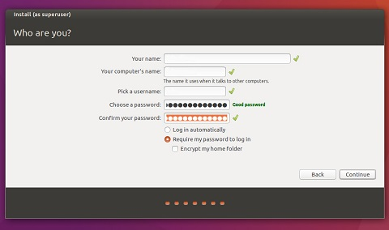

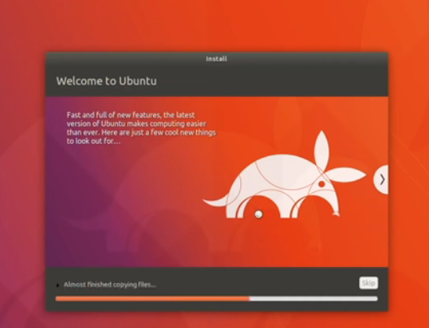
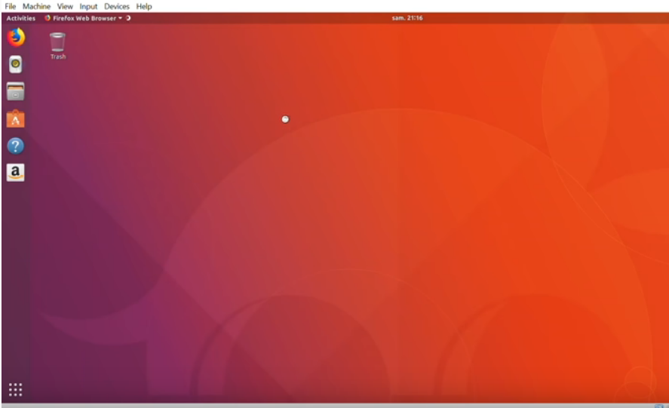
Wait until the reboot is completed and you will enter into the linux .

Following the above process we can easily install ubuntu or any other linux distribution in our desktop.

Conclusion : Since it is my first time installation of any operating system in my laptop it is not easy to me . I take help from Linux website and following the instruction as they provided I have successfully installed ubuntu in my laptop . Hope I will start a better journey with Linux.

